**AWS Elastic Beanstalk**

* AWS Elastic Beanstalk is an AWS Service that we can use to deploy applications, services. It provides provisioned scalability, loadbalancing and high availability
* It supports the applications developed in languages
  + Java
  + .NET
  + PHP
  + Python
  + NodeJS
  + Ruby
  + GO
* It also supports Docker and also common type of servers like APACHE, NGINX and IIS
* Elastic Beanstalk enables the automated deployments and management of applications on the AWS Cloud.
* Elastic Beanstalk can launch AWS resources automatically with Route53, AWS AutoScaling, Amazon EC2 and AWS RDS and also it allows us to customize additional AWS resources
* Lets try to create a Sample Elastic Beanstalk application deployment 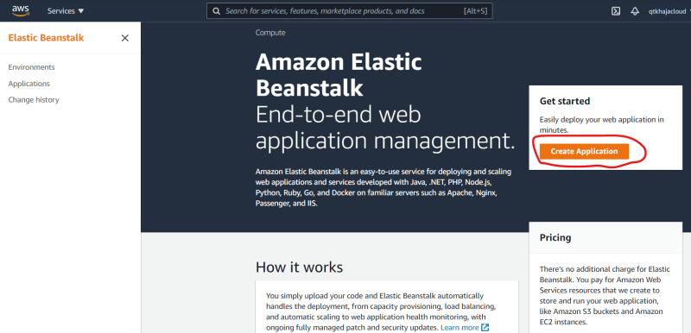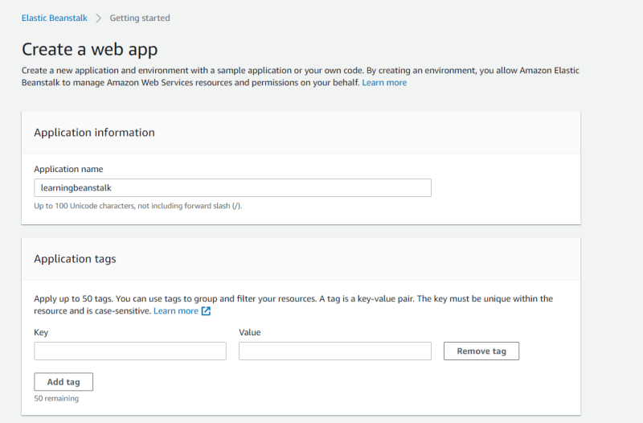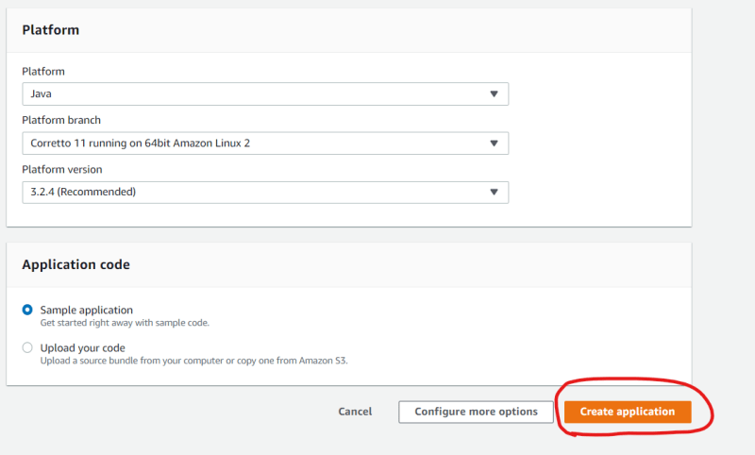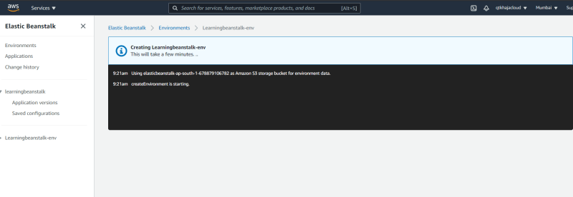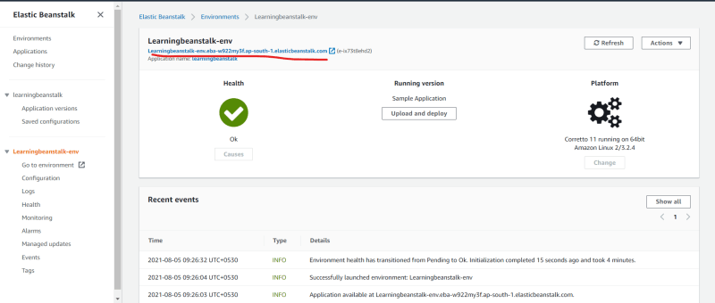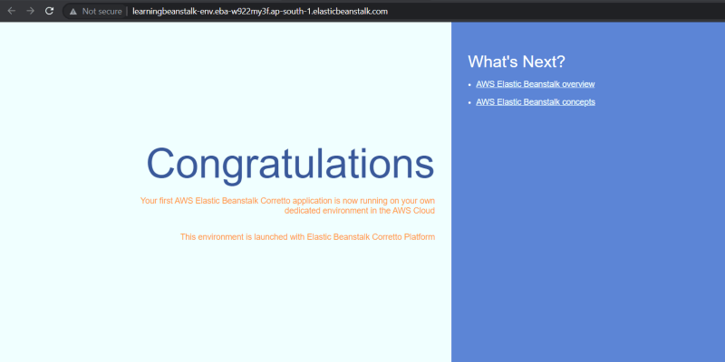
* Once you have done this terminate the environment as shown in class
* Deploy applications without worrying about managing the underlying technologies including
  + Components
    - Environments
    - Application Versions
    - Environment Configuration
  + Permission Model
    - Service role
    - Instance Profile
* Implementation Responsibilities 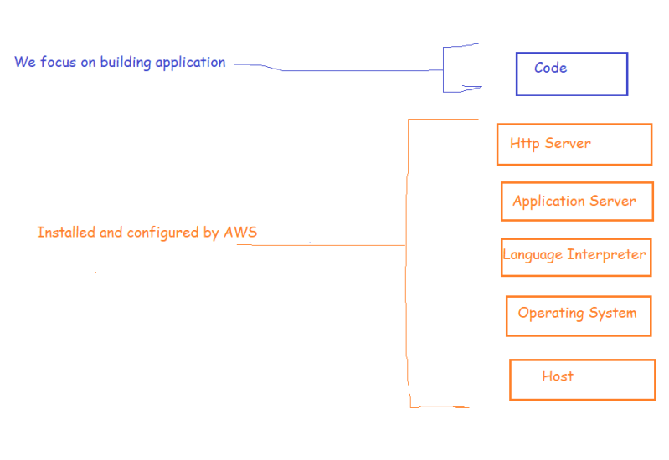

**Elastic Beanstalk concepts**

* Application: Elastic Beanstalk focuses on managing your applications as environments and all of the resources to run them. This application is logical collection of Elastic beanstalk components including environments, versions and environment configuration
* Application Version: An application version refers to specific iteration of deployable code for a web application. An application version points to an AWS S3 object that contains deployable code (WAR file)
* Environment: Environment is collection of AWS resources running an application version.
* Environment tier:
  + Web Server Environment Tier (Web Application/Site)
  + Worker environment tier ( A backend environment )
* Environment Configuration: This identifies a collection of parameters & settings that define how environment and its associated resources behave.
* Saved Configuration:
  + This is a template that we can use as a starting point for creating unique Environment Configurations.
* Platform:
  + Platform is a combination of operating system, programming language runtime, webserver, application server and Elastic Beanstalk components